**Describe Hub, Switch and Router**

**Hub:** The hub is a network device that connects multiple devices together. Whenever a device request any information from any network, it sends the request to the hub through the cable. The hub then receive the request and send to the whole network.It doesn't intelligently manage data flow. It simply repeats the data to all connected devices, leading to potential congestion and inefficiency.It is simply a central place where things are shared without much organization.

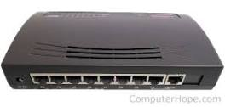*Hub*

**Switch:** Switch is a smarter network device which act as a controller that allows devices on your network to communicate with each other as well as other networks.It learns the devices' addresses and sends data only to the intended recipient, improving data transfer speed and reducing network congestion.A switch is a clever organizer that makes sure things go to the right person

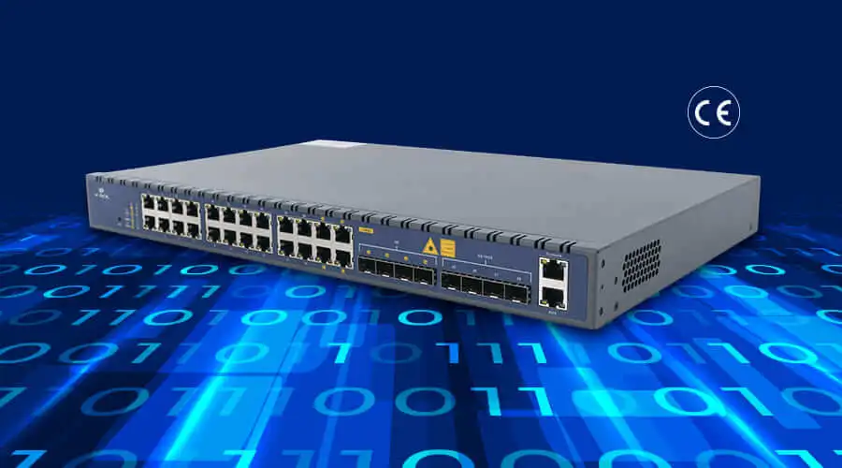*Switch*

**Router:** This network device helps analyze data sent across a network by acting as a dispatcher and automatically selects the best route for data to travel and send it. It enables you to share a single internet connection with multiple devices and saves money. We can say a router is a magical map reader that finds the best way to send things to faraway places.

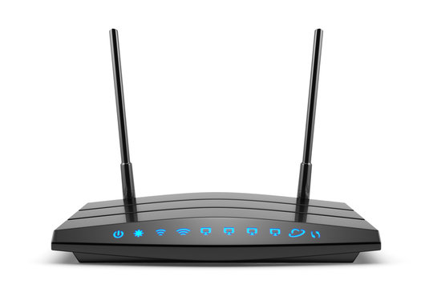*Router*

**What is the OSI model?**

The OSI (Open Systems Interconnection) model is a conceptual framework used to understand and describe how different network protocols and communication technologies work together to enable communication between devices in a network.

**Explain the different layers of the OSI model.**

The OSI has 7 layers which are

1. Physical layer
2. Data link layer
3. Network layer
4. Transport layer
5. Session layer
6. Presentation layer
7. Application layer

The descriptions usually go from top to bottom, usually from layer 7 to layer 1.

**Application layer:** The application layer is the topmost layer and represents the actual network applications used by users, such as web browsers, email clients, and file transfer programs. Application does not reside on this layer. It is the closest to the end user which implies it receives information directly from the user and displays incoming data to the user.

**Presentation layer:** The presentation layer is responsible for the translation, encryption,compression and decryption of data. It ensures data from different application can be understood by the receiving device.

**Session layer:** Session layer is when two or other networked devices need to speak to each other, a session is created.The session layer establishes, maintains, and terminates communication sessions between applications on different devices. It allows multiple applications to share the same network connection.

**Transport layer:** This layer maintains end to end communication between devices. It deals with the coordination of data transfer between the end system and host. It determines how much data to send, where it goes and at what rate.

**Network layer:**This layer is responsible for packet forwarding, including routing through different routers.It determines the best path for data to travel from the source to the destination across multiple network segments.

**Data link layer:**The data link layer is responsible for error detection and correction, as well as organizing data into frames to be sent over the physical layer. It provides node to node data transfer between two connected nodes.

**Physical layer:** The physical layer represents the electrical and physical representation of the system.It defines specifications for cables, switches, and other hardware components involved in transmitting raw bits.This is usually the first place to check when a networking problem occurs, many networking pros go right to the physical layer to check that all of the cables are properly connected.

**What is the meaning of Network Protocols?**

Network protocols define the standards and procedures for how these devices should format, transmit, receive, and interpret data during communication.

Write briefly on the different protocols HTTP/HTTPS, TCP/IP, SMTP, UDP and more.

**HTTP and HTTPS:** HyperText Transfer Protocol and HyperTextTransfer Protocol Secure are protocols that enable communication between web browsers and web servers. HTTP is the standard protocol for transmitting data on the internet, while HTTPS adds an extra layer of security through encryption to protect sensitive data during transmission.

**TCP/IP:**Transmission Control Protocol/Internet Protocol, these are a set of networking protocols that are the foundation of communication on the internet and many other computer networks.It is the essential protocol suite that enables the vast, interconnected global network we know as the internet.TCP deals with data delivery and reliability, while IP handles addressing and routing in the TCP/IP protocol suite. They work together to enable effective and efficient communication over the internet and other networks.

**SMTP:**Short Mail Transfer Protocol is used for sending and receiving email messages between email servers.

**UDP:**User Datagram Protocol is a connectionless transport protocol used in the TCP/IP protocol suite. Data is sent in small units called datagrams without establishing a connection between the sender and receiver beforehand. UDP is used where speed and low latency are more important than reliability, such as real-time audio and video streaming, online gaming

**What is a Firewall?**

A firewall is a security system or software that acts as a barrier between a trusted internal network (like a home or company network) and an untrusted external network (like the internet). Its main purpose is to monitor and control incoming and outgoing network traffic to prevent unauthorized access, potential threats, and data breaches.

Firewall can be hardware or software based.

**Explain DNS**

Domain Name System is used to translate human-readable domain names into IP addresses that computers can understand.It is like a phonebook for the internet. Instead of using complicated numbers (IP addresses) to find websites and other online resources, we use easy-to-remember names (domain names).

**Define Latency**

Latency is simply the speed of the internet.Network latency is defined as the amount of time it takes for a packet of data to get from one particular point to another.Latency is typically measured in milliseconds (ms) and is influenced by various factors such as the distance between the sender and receiver, the number of network devices the data passes through, and the processing time at each point.

**Define Caching**

Caching is the process in which an area of a computer’s memory is devoted to temporarily storing recently used information.Caching is commonly used in various computing environments, such as web browsers, operating systems, and network devices, to improve performance and reduce response times.

**Define Wide Area Network**

A Wide Area Network (WAN) is a type of computer network that spans a large geographical area, typically covering multiple cities, countries, or even continents. WANs are designed to connect devices and networks across long distances and are often used to facilitate communication and data exchange between remote locations.

**What is an IP address?**

An IP address is an address used in order to uniquely identify a device on an IP network.It defines unique IP addresses for devices and allows data to be forwarded to the correct destination.

**Define a routing Information Protocol.**

Routing Information Protocol (RIP) is one of the oldest and simplest interior gateway protocols (IGPs) used in computer networks. It falls under the category of distance-vector routing protocols, which means it determines the best path for data to travel based on the distance (number of hops) to the destination network.

**"193.16.20.35/29" What is the Network IP, number of hosts, range of IP addresses and broadcast Ip from this subnet?**

Network IP

Allowed number of Bits = 32,

29 bits up and 3 bits down = 29-1’s and 3 0’s => 11111111.11111111.11111111.11111000

The Logical AND for the binary form of the IP address and subnet will give the Network IP

**193.16.20.35 => 11000001.00010000.00010100.00100011**

**29 => 11111111.11111111.11111111.11111000**

**11000001.00010000.00010100.00100000 => 193.16.20.32**

**The Network IP => 193.16.20.32**

**Number of host = 2 **(32 - subnet value) - 2**

**Number of host = 2**(32 -29) - 2**

**Number of host = 2**(3) - 2**

**Number of host = 8 - 2**

**Number of host = 6**

To get the broadcast IP, the subnet value for the 29 bits up - 29 0’s and 3 1’s

**11111111.11111111.11111111.11111000 => 00000000.00000000.00000000.00000111**

**Broadcast IP =** the logical OR for the new subnet value and IP address

**193.16.20.35 => 11000001.00010000.00010100.00100011**

**New subnet value => 00000000.00000000.00000000.00000111**

**11000001.00010000.00010100.00100111 => 193.16.20.39**

**Broadcast IP = 193.16.20.39**

Therefore, the range of IP Address are between Network IP and Broadcast IP

* **193.16.20.33**
* **193.16.20.34**
* **193.16.20.35**
* **193.16.20.36**
* **193.16.20.37**
* **193.16.20.38**